**Benchmark of windowed aggregations**

By: Patrick Lehmann, TU Berlin

Mentor: Jeyhun Karimov

**Table of contents:**

1. Motivation/Goals
2. Project setup
   1. Latency
   2. Dataflow
   3. System setup
   4. Experiment setup
3. Results
   1. Experiment “workload”
   2. Experiment “window length”
   3. Experiment “sliding size”
4. Conclusion

# Motivation/Goals

Due to the various number of different streaming engines like Flink(), Spark(), Storm(), Apache Samza, Apache Apex, and Google Cloud Dataflow, it is from high interest to know how these systems behave in different situations. Especially as all have different characteristics and approaches in data processing and therefore their underlying architecture. For example, Spark uses microbatches to process data streams while other systems like Flink can process rows after rows of data in real time. Because many factors influence the performance this benchmark focuses on windowed aggregations. Therefore, it will analyze parameters like the window length, the sliding length, and the workload. To measure the performance the latency will be computed.

# Project setup

To generate the data stream a Taxi Ride file() was used in this benchmark. This contains of several taxi rides in the USA with parameters like starting time, number of passenger, and arriving time. This file was injected into Apache Kafka(), which produced the data stream that will be received by the streaming systems. This benchmark will compare the data streaming systems Flink and Spark. Both systems are used in practice by several companies and organizations. They also distinguish themselves through their basic approaches as described before. The Aggregation consists of basic map-reduce functions and computes the average numbers of passengers in the taxi rides in the specific windows.

## Latency

To measure the latency several ways exist. As Spark does not provide event time processing this benchmark basically calculates the processing time as latency. Therefore a timestamp is assigned for each tuples as soon as it enters the streaming system and another one before the resulting tuple leaves the system. As there are several input timestamps and just one output timestamp the timestamp of the latest incoming tuple is used for input. The difference between both is the latency.

Latency = timestamp_result – maximum(timestamp_1,…,timestamp_N)

## Dataflow

The flow of the data and operations is following:

1. Read file and push tuples into Kafka topic
2. Streaming system reads from Kafka topic and assigns the first timestamp
3. Streaming system assigns tuples regarding their key into sliding windows
4. In each window with reduce functions the average number of passengers and the maximum timestamp is computed
5. The second timestamp is assigned
6. The result get printed

Figure 1: Dataflow model

**Data file**

**Kafka**

**Flink/Spark**

**Output**

**Timestamp**

**Timestamp**

**Latency**

## TODO Show example of aggregation

## System setup

The benchmark was run on a cluster with 10 nodes and 48 cores each.(TODO more specs) The setup was:

* 1 Master node
* 5 Worker nodes
* 1 Kafka node
* 1 Producer node
* 1 Zookeeper node

Flink was run with its default configurations while for Spark the backpressure mechanism had to be enabled for consistency.

## Experiment setup

The experiments were designed to analyze the influence of the window length, sliding length, and workload on the latency for both systems. Therefore 3 experiments were conducted, where each one parameter was changed at a time. The experiments were conducted at least twice to reduce some of the deviation.

Experiment “workload”:

* Window length: 3 seconds
* Sliding length: 2 seconds
* Workload: 50000 – 800000 tuples per second

Experiment “window length”

* Window length: 1 – 30 seconds
* Sliding length: 1 second
* Workload: 100000 elements per second

Experiment “sliding length”

* Window length: 30 second
* Sliding length: 1 – 30 seconds
* Workload: 100000 elements per second

For all experiments in Spark the batch size was set to 1 second. This is a bit rough as the performance of Spark is depending on this size, but to find the optimal size experiment would have done with a different batch size as there is no formula for the optimal measurement. Because this benchmark is more interested in the effect of the parameters than what could be the best latency, the value was set to 1 second for all experiments.

# Results

## Experiment workload

In this experiment the influence of the workload was analyzed. Basically, what to expect would be that with higher workload the number of elements to compute in each window would increase and therefore the latency would continuously increase as well.

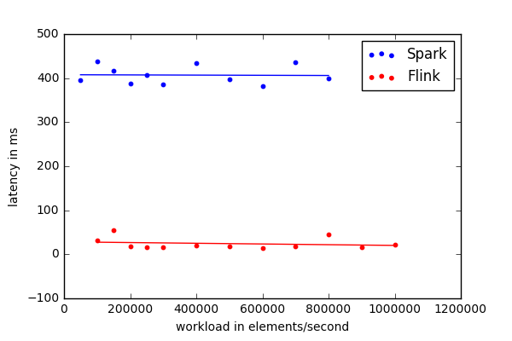

Figure 2: Workload for window length = 3s and sliding length = 2s

This figure is a scatter plot with one dot for each experiment and one regression line for each system. In contradiction to the previous expectations the latency stays constant for each system. Just a difference between both systems if observable. While Spark has a latency around 400 ms, Flink has a very low latency about 30 ms.

In figure 3 is the behavior of the latency in one experiment (the same as before) depicted. Here is shown that the latency stays for both system even for the same experiment approximately constant over time at around the same latency as in figure 2.

To explain the constant number of latency a closer look at the internally backpressuring of both systems is needed.

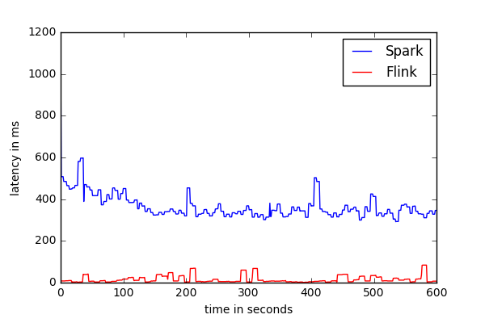

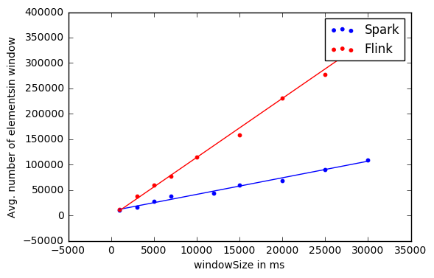

Figure 3: Latency over time for Flink and Spark

### Backpressuring

The backpressuring is a mechanism in a data streaming system where it is receiving data at a higher rate than it can process. If a situation like this happens it is more efficient to reduce the processing data than trying to process all data at once, because it probably results in a delay that the system cannot recover from easily. Both streaming systems have a built-in backpressure mechanism, although they behave differently. The problem with the backpressuring for the latency is that the latency in this benchmark is computed with as the difference of the data between entering the system and exiting it. And if the backpressure mechanism limits the number of elements that are going into the system for higher workload the latency gets independent from the workload and stays constant.

In figure 3 and 4 we can see how a streaming job run with and without backpressuring if the number of receiving tuples increase. In figure 3 are just 5 “blocks of tuples” incoming which also can all be processed. In figure 4 are 9 “block of tuples” coming from the source, but with due to backpressuring are only again 5 “blocks” entering the system. As the timestamps are assigned to the tuples just when they enter the systems, the latency stays the same even when the workload increases.

Processed tuples

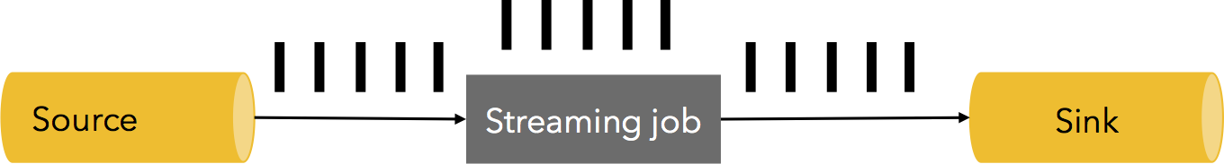

Figure3: Streaming job without backpressuring

Source: http://data-artisans.com/how-flink-handles-backpressure/

Processed tuples

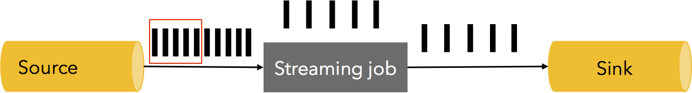

Figure4: Streaming job with backpressuring

Source: <http://data-artisans.com/how-flink-handles-backpressure/>

In figure 6 are the number of elements that are processed in each window depicted to show how the backpressure mechanism operates. Here one experiment was run with window length of 25 seconds, sliding length of 1 second, and a workload of 300,000 elements per second. We see that Spark is in the beginning trying to keep up with amount of workload which leads into a delay of computation and it must reduce the input to nearly 0. Afterwards it increases the input slowly until it stays constant at around 90,000 elements. Flink in the opposite starts with less elements, but increases them faster. After a short period, it stays constant at about 130,000 elements. There one can see that for this configuration Flink performs better with an average about 130,000 over Spark with just 90,000 elements.

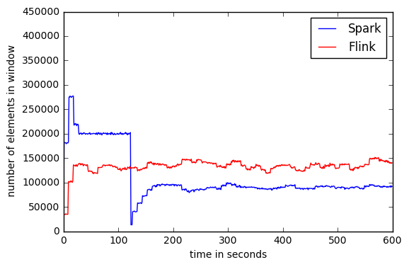

Figure 6:

With the learned knowledge of the backpressuring it makes sense to measure the average number of processed tuples for each window, which is basically the throughput, instead of the latency. Figure 7 shows an example for that. Again, these graphs seem to be constant. This happens, because with a high workload the systems´ backpressuring limits the input to the computed optimal number and the number of elements that are getting processed are getting independent of the workload. On one hand this shows good which systems has a better throughput, but on the other hand it does not exactly tell how these systems perform regarding to the specific parameter. Hence, a different metric was used to show also the influences of the parameters. As the possible input increases with higher workload, one might be interested in the percentage of the number of tuples that could be processed. This is shown in figure 8. This figure shows that Flink can process with lower workload about 80 % of the incoming tuples, but is continuously decreasing as the workload increases. Spark performs much worse as with low workload it could just process about 40 % of the workload and with a workload of 200,000 elements the performance rate is lower than 20%.

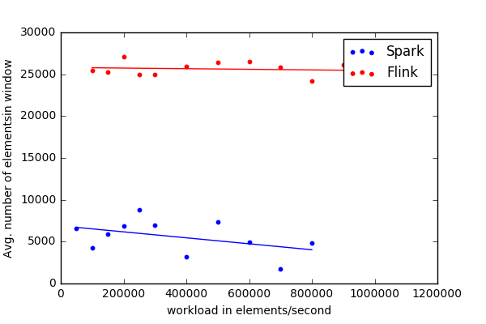

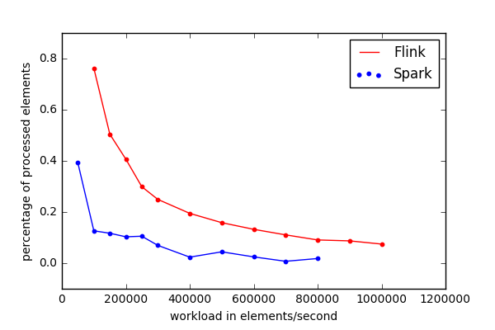

Therefore, in general it was shown that the latency is not sufficient to do a benchmark for streaming systems if they have backpressuring enabled as this mechanism fixes the latency to be approximately constant. Therefore, it is helpful to analyze the throughput as well. In this benchmark for both values Flink was performing better, but both measurements stayed constant over time. The percentage of elements that were processed gave a better view on the behavior regarding the workload. While Flink was performing way better for smaller workload it was also increasing faster, but performed better than Spark for the whole experiments. Spark could not keep up with already low workload and performing terrible for workload over 100,000 elements per second.

## **Experiment window length**

In this experiment the influence of the window length was analyzed. Therefore, an experiment was conducted that had a workload of 300,000 elements per seconds, a sliding size of 1 second, and the window length was changed from 1 second to 30 seconds. To expect would not be a large influence of the window length, because the number of new elements that would come into the streaming system is determined by the sliding length, which stayed constant for this experiment. On the other hand, the number of elements that are in the windows should increase with larger window length and consume therefore more memory which could affect the performance.

Figure 9 shows the average number of elements in the windows for increasing window length. Although for both systems the number of elements are increasing it is obvious that their slopes are different in height. Flink seems to better handling the increasing window length as Spark does. But even for Flink one can already see the window length influences the performance as with doubling the window length the number of elements are not doubling. This is show better in figure 10 where the percentage of processed elements is shown. Both systems have a negative slope which means they are influenced by the window length. The slope of Flink is however not as much affected as the one of Spark is. To note here is the outlier of Spark for the window length of 1 second. As the sliding length was 1 second as well the window was in this experiment a tumbling window. For those tumbling windows Spark seemed to perform significantly better than for sliding windows in other experiments. This might explain that outlier, but further researches would be required to confirm this.

In summary, it was show that the window length has a slight influence on Flink´s and a larger one on Spark´s performance.

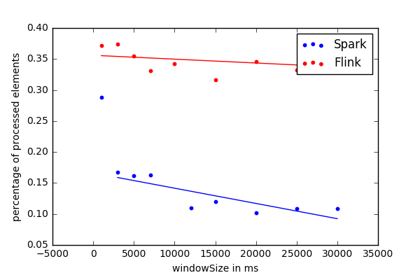

## Experiment sliding length

For the sliding length, an experiment was conducted with a workload of 300,000 elements per second, a window length of 30 seconds, and a sliding length from 1 second to 30 seconds. In figure 11 is the percentage of processed elements shown. This graphs would be the same, except the scale, for the measurement of average elements as the input rate of all experiments was the same. The latencies were again constant, because of the backpressuring. The behavior of Flink´s processing rate is approximately constant with a slight negative tendency. That tendency might be explained by some variations. Spark´s graph just performing slightly better for small sliding length. Afterwards the processing rate is with under 5 percent performing poorly. For larger sliding sizes the performance could can better with an increasing batch size as this was or all experiment constant with 1 second. Compared to Flink performance Spark´s performance would even with dynamic batch sizes much worse. The large difference can be explained by the high workload and window length. As seen in previous experiment both parameters decrease Spark´s performance larger. For this experiment, they seem to add their effects which would explain the large difference between both systems. To note again, is an outlier in Spark´s performance at 30 seconds sliding length. As this is the same size as the window length, the underlying window is a tumbling window. Like in the previous experiment it seems that Spark´s performance is better for tumbling windows.

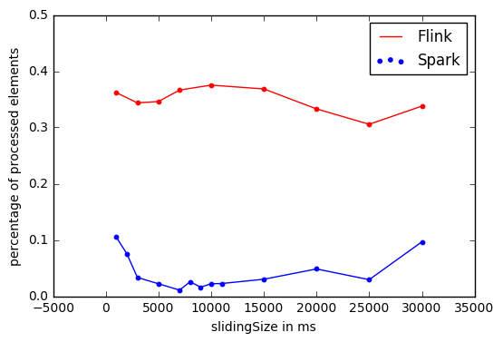

# Conclusion

In summary, it was shown that the latency is not the only measurement needed to explain the behavior of the systems. This happens if the backpressure mechanism is enabled, because this mechanism limits the receiving rate and the measurement of the latency in this benchmark was using the processing time. Therefore, the number of elements to process and measure the latency stays approximately constant. Furthermore, another metric was used to indicate the performance. This was the rate of elements that were processed in each window. With that metric the behavior of the throughput regarding the parameters could be shown.

For the experiment “workload” both systems were highly decreasing with increasing workload.